Position details
Group: | Infrastructure and Design
Branch: | City Projects
Team: | Queen Victoria Market Precinct Renewal (QVMPR)
Reports to: | Principle Project Manager, QVMPR
Position No: | C8094
Classification: | 5
Financial management | Nil
Direct reports: | Nil
Volunteers being supervised by this position: | Nil
Job Family: | Project Management

Our Vision and the Way we Work
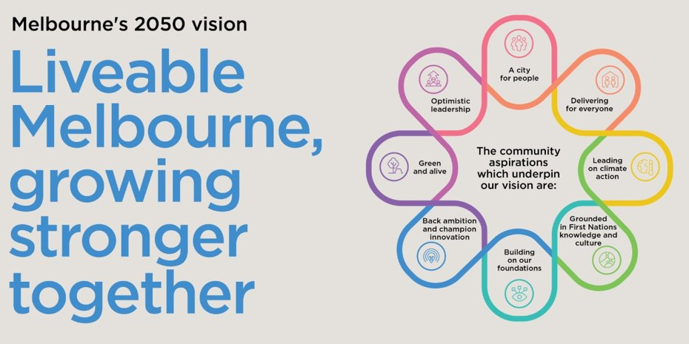

The way we work is underpinned by our Values:
- INTEGRITY is being honest and reliable in all dealings with others and conducting activities professionally and ethically.
- COURAGE means to step out of our own comfort zone and accept responsibility for the consequences of our own actions.
- ​​​​​ACCOUNTABILITY means to take personal responsibility for decisions and actions to achieve agreed outcomes.
- RESPECT means to value the contribution and individuality of others and contribute to healthy working relationships.
- EXCELLENCE means we aim to achieve the highest standard and best possible result in everything we do.

Team context
City Projects Branch
City Projects is responsible for the planning, design, and delivery of the City of Melbourne’s major capital works program. The branch leads complex, high-value infrastructure and public realm projects that support the City’s long-term strategic objectives, ensuring high standards of design, sustainability, and community outcomes.
The branch operates within a structured governance framework and works collaboratively across Council divisions, stakeholders, and delivery partners to ensure projects are delivered safely, on time, within budget, and in line with approved business cases and strategic priorities.
City Projects plays a key role in managing project risks, stakeholder engagement, procurement, and contract delivery, while maintaining continuity of city operations and minimising disruption to the community. The team brings together multidisciplinary expertise across project management, engineering, urban design, and construction delivery to support the successful implementation of complex programs such as the Queen Victoria Market Precinct Renewal.
Queen Victoria Market Precinct Renewal (QVMPR)
City Projects is responsible for the planning, design, and delivery of the City of Melbourne’s major capital works program. The branch comprises a number of delivery teams, including the Queen Victoria Market Precinct Renewal (QVMPR) team, which is responsible for delivering one of the City’s largest and most complex infrastructure programs.
The City of Melbourne is undertaking the largest infrastructure investment in the City’s history – the Queen Victoria Market Precinct Renewal (QVMPR), which includes renewal and upgrade to the existing market ($268 million) as well as delivering public private partnership projects within the precinct ($1 billion).
The Queen Victoria Market Precinct Renewal aims to:
- Ensure the future viability of the Market as a profitable business asset for the City of Melbourne and the Market’s vendors by providing modern facilities within the heritage character of one of the world’s largest markets
- Enhance the City’s northern precinct by providing community space and effective access to the market
- Adopt a best practice approach to stakeholder management throughout the life of the Program
- Deliver a world class market and surrounding precinct for all Melburnians

The Program’s success in meeting all objectives will depend on an effective partnership between City of Melbourne and its subsidiary company, the Queen Victoria Market Pty Ltd (QVM). City of Melbourne is responsible for the financing and delivery of the QVMPR Program and contributes knowledge and expertise to ensure that the project is delivered on time, to the required budget and in accordance with the approved Master Plan. QVM brings knowledge and expertise to ensure that the project addresses the current and future needs of the traders and customers of the market and contributes to the best business models and approaches for the Market’s operations.

Position Purpose
The Assistant Project Manager contributes to the objectives of Precinct Renewal projects by providing project coordination, project management and administrative support to assist in the overall delivery of renewal program and key project deliverables.
The key objective of this position is to provide project coordination on key renewal projects. The Assistant Project Manager will work collaboratively with the QVMPR team, City Projects team and the QVM team to develop (where necessary), coordinate and report on detailed project plans. The Assistant Project Manager will be responsible for maintaining action, task and risk registers and coordinating overall timelines under the guidance of the Principal Project Manager. This role will also provide general administrative support to the team as well as supporting the projects and Principle Project Manager to deliver the projects.

Key Accountabilities
- Provide support to the Principal Project Manager, Project Managers in managing and coordinating all aspects of the Program as well as creating and updating schedules and other project management documentation.
- Manage components of projects under the guidance of the Principle Project Manager.
- Assist in the preparation of documentation required for Expression of Interest, Request for Proposal and tender documentation.
- Coordinate and manage all Program and Project team meetings, ensuring all meetings are scheduled appropriately, agendas and reports are prepared on time and action items are recorded and distributed to all members.
- Liaise with key participants of the Program to ensure deadlines are met within the required timeframes.
- Liaise with key internal stakeholders across Council as required to coordinate and facilitate QVMPR outcomes.
- In conjunction with Program and Principle Manager and Finance, Reporting and Risk Coordinator assist with the monitoring of overall Program costs to ensure delivery remains within budget.
- In conjunction with the Finance, raising purchase orders, processing invoices, reporting and risk Coordinator, provide assistance in project risk management procedures, including the delivery of timely reporting.
- Respond to ad-hoc requests for information and develop responses in consultation with members of the Program team.
- Provide project support and general administrative support to the QVMPR team as requested. including preparation of meeting materials, Powerpoint presentations correspondence and draft briefing notes.

Key Relationships
Internal | External
- City Projects  - City Design  - Relevant internal divisions and branches across Council  - Councillors  - Executive Leadership Team | - Professional consultants and delivery partners  - Queen Victoria Market Pty Ltd  - Key regulatory authorities (e.g. Heritage Victoria, Melbourne Water)  - Other government agencies, stakeholders, and community representatives as required

Key Selection Criteria
All CoM employees will demonstrate an ability to articulate and demonstrate benefits of positive culture and values.
In addition, the position will require:
- Minimum of 1 years of relevant assistant project manager/ contract admin experience within construction, architecture and/or engineering.
- Experience creating, updating and managing schedules using MS Project.
- Strong computer skills, including MS Word, MS Excel, MS PowerPoint and MS Outlook.
- Exceptional interpersonal skills; the ability to work well with people from many different disciplines with varying degrees of technical experience; competence in clear, concise and tactful communication with Managers, clients, peers and other team members.
- Strong attention to detail and exceptional organisational skills.
- Excellent time management and prioritising skills being able to manage many issues at once, and being responsible for ensuring all matters are handled in a timely, professional manner, with stakeholders informed of progress as appropriate.
- Highly developed written, graphic and oral communication skills.
- A high level of initiative and independence and the ability to establish own priorities and work with limited direction and proven ability to work in a team environment.
- Highly developed customer service skills and demonstrated ability to be professional, discrete, and courteous.
- Proven ability in establishing and maintaining strong relationships with internal and external stakeholders.

Inherent Requirements
The reference to the Inherent Requirements for this position is DM 9233657.

Commitment to Child Safety
All CoM employees are required to hold a valid Working with Children Check (WWCC).
The City of Melbourne is a child-safe organisation with zero tolerance for child abuse. All children and young people have the right to be and feel safe. We embed child safety into daily practice and require all employees, volunteers and contractors to understand, prevent, detect and report any concerns relating to child safety.

